DAYANANDA SAGAR COLLEGE OF ARTS, SCIENCE AND COMMERCE

DEPARTMENT OF COMPUTER APPLICATIONS,
BANGALORE -111.

Master of Computer Applications
MCA 2024-2026


A Project Report
On
Environmental Health Intelligence & Early Warning System

Submitted by

Kushal Kumar M
(P03CJ24S126052)

In partial fulfillment of the requirements for the award of the degree of Master of Computer Applications, Bangalore University Under the guidance of

Prof.Kohila Kanakalakshmi, DSCASC | External Guide  Name  Designation

DAYANANDA SAGAR COLLEGE OF ARTS,
SCIENCE AND COMMERCE

DEPARTMENT OF COMPUTER APPLICATIONS,
BANGALORE -111.

Master of Computer Applications
MCA 2024 – 2026.

CERTIFICATE
This is to certify that Kushal Kumar M (P03CJ24S126052) of IV semester MCA, has satisfactorily completed the project work during June 2026 to October 2026, entitled “Environmental Health Intelligence & Early Warning System” in partial fulfillment of the requirements for the award of the degree of Master of Computer Applications under Bangalore University.

Mr./Ms./Dr.  Designation,  DSCASC | Prof. Dr. Kumudavalli M V  Deputy Director  DSCASC
Date: Signature of the Examiners 1.

2.

CONTENT
- Abstract……………………………………………………………………<page no>
- Acknowledgement………………………………………………………...<page no>
- Certificate from Company
- Student declaration……………………………………….………………<page no>
- Introduction………………………………………………………………
- Company profile
- Scope of the system
  - Existing system
  - Problem statement
  - Proposed system
- System analysis
  - Review of literature
  - Review of research
  - Feasibility study
  - Tools technology
  - Hardware and Software requirements
- Planning
  - Overall description
    - Product perspective
    - Product functions
  - User modules
  - Functional and Non-functional requirements
- System Design
  - System perspective
  - DFD diagrams
  - UML diagram.
  - Database diagram
  - Table Structure
- Screen-shots
- Software testing
  - Test cases
    - Test case for Student
    - Test case for Admin

- Conclusion
- Limitations
- Future enhancement
- Reference
- Appendix
  - User manual
- Bibliography

ABSTRACT
Air pollution has emerged as one of the most severe environmental health hazards globally, contributing significantly to cardiovascular disease
ute respiratory illness, and reduced life expectancy in urban populations. Traditional Air Quality Index (AQI) monitoring systems suffer from critical limitations: they present static, macro-level index numbers without considering individual health vulnerabilities, lack predictive early warning capabilities for sudden environmental spikes, and fail to offer actionable, personalized mitigation advice.
To resolve these challenges, this project presents the Environmental Health Intelligence & Early Warning System (EHI-EWS)—a full-stack, AI-powered microservices platform designed for real-time AQI tracking, predictive health exposure scoring, machine learning anomaly detection, and conversational AI assistance. Built on a modern 3-tier architecture, EHI-EWS integrates a React 18 / TypeScript frontend, a Node.js / Express 5 REST API gateway with MongoDB Atlas, a Python FastAPI Machine Learning engine, and an intelligent Environmental Virtual Assistant (EVA).
The system processes multi-pollutant telemetry data (PM2.5, PM10, NO2, SO2, CO, O3) and ambient weather variables, computing a dynamic Environmental Exposure Index (EEI) personalized to user health profiles (e.g., asthma, COPD, age, outdoor exposure intensity). The Python ML microservice employs Isolation Forest and Z-Score rolling window algorithms to detect localized pollution spikes and abnormal sensor readings, evaluating model accuracy with standardized metrics (RMSE, MAE, R²). Concurrently, EVA utilizes natural language processing and spatial geocoding APIs to provide safe travel itineraries and locate nearby medical facilities during environmental emergencies.
Empirical evaluation demonstrates high predictive reliability, automated alert dispatch under sub-200ms API response latency, and seamless GIS map overlay rendering. EHI-EWS empowers citizens, healthcare administrators, and urban planners to transition from passive pollution awareness to proactive, health-centric environmental risk mitigation.

ACKNOWLEDGMENT

I would like to take this opportunity to express my heartfelt gratitude to everyone who supported me throughout this internship and the preparation of this report.

First and foremost, I am deeply thankful to <internship company> for providing me with the opportunity to work on this <domain of the project>development project. My special thanks go to <External Guide> and the entire team for their guidance, encouragement, and constant support during the internship.

I extend my sincere gratitude to my project internal guide, <Internal Guide {Mr./Ms./Dr./name, designation, DSCASC for her invaluable advice, feedback, and support throughout this internship. Their mentorship played a crucial role in the success of this project.

I would also like to express my sincere gratitude to Dr. Balu L, our Principal, for his constant encouragement; Mr. Hemanth Uppala, our Vice Principal, for his valuable guidance and motivation; and Dr. Kumudavalli M V, our Deputy Director, DSCASC, for providing the platform and opportunity to undertake this project.

A special thanks to my family and friends, whose constant encouragement, patience, and support helped me stay focused and motivated during this entire journey. Without their belief in me, this project would not have been possible.

Name of the Student

INTERNSHIP COMPLETATION LETTER



STUDENT DECLARATION

I Kushal Kumar M (P03CJ242126052), hereby declare that the internship report titled Environmental Health Intelligence & Early Warning System is the result of my own work and has been carried out during my internship at Terra Web Solution.This report has not been submitted to any other institution for any academic qualification or diploma.
I further declare that all the data and information used in this report are true to the best of my knowledge and have been obtained and utilized ethically during the course of my internship.
I submit this report in partial fulfilment of the requirements for the degree of Master of Computer Applications at Bangalore University.

Kushal Kumar M
P03CJ24S126052

INTRODUCTION

Background
Air pollution is one of the most serious environmental and public health problems of the modern world. Rapid urbanization, increasing population density, growing vehicle usage, industrial emissions, construction activities, energy consumption, and other human activities have significantly contributed to the deterioration of air quality in many cities. As urban areas continue to expand, the number of people exposed to polluted air on a daily basis also increases. Air pollution is therefore not only an environmental concern but also a major public health challenge that requires continuous monitoring, analysis, and preventive action.
The quality of air surrounding an individual can vary significantly depending on geographical location, traffic density, industrial activity, weather conditions, time of day, and other environmental factors. Pollutants released into the atmosphere may remain concentrated in certain areas, particularly during unfavorable weather conditions. Consequently, two locations within the same city may experience different pollution levels at the same time. This makes location-based environmental monitoring an important component of an effective air-quality management system.
Among the various air pollutants, particulate matter is considered particularly harmful. Fine particulate matter, commonly referred to as PM2.5, consists of particles with an aerodynamic diameter of 2.5 micrometers or smaller. Because of their extremely small size, these particles can penetrate deeply into the respiratory system and may enter the bloodstream. Long-term or repeated exposure to elevated concentrations of PM2.5 has been associated with respiratory and cardiovascular health problems. Other pollutants such as PM10, nitrogen dioxide (NO₂), sulfur dioxide (SO₂), carbon monoxide (CO), and ozone (O₃) can also contribute to adverse environmental and health effects.
The effects of air pollution are not identical for everyone. Children, elderly people, individuals with respiratory conditions, people with cardiovascular vulnerabilities, and people who spend long periods outdoors may be more sensitive to poor air quality. For example, an air-quality condition that may be tolerable for a healthy adult could represent a considerably higher risk for an individual with asthma or chronic obstructive pulmonary disease (COPD). Therefore, environmental information should ideally be interpreted in relation to the characteristics and exposure patterns of the individual.
Air-quality monitoring systems commonly use the Air Quality Index (AQI) as a simplified representation of pollution conditions. AQI allows complex pollutant measurements to be represented through a single index that is easier for the general public to understand. Government agencies, environmental organizations, websites, and mobile applications commonly use AQI information to communicate the severity of air pollution.
Although AQI is useful for environmental awareness, it provides a generalized representation of air quality. It does not necessarily describe the personal risk faced by every individual. The same AQI value can have different implications depending on an individual's age, health condition, exposure duration, and sensitivity to pollutants. Therefore, there is a need for systems that can move beyond simply displaying environmental values and instead provide personalized interpretation of those values.
Another challenge associated with conventional environmental monitoring is that many systems focus primarily on the current state of the environment. Users may be able to see the current AQI or pollutant concentration, but they may not receive sufficient information about whether the situation is improving, deteriorating, or developing into an unusual event. Sudden pollution spikes may occur because of traffic congestion, industrial activity, weather changes, or other temporary events. Detecting such events at an early stage can be valuable for reducing exposure.
This creates a need for an environmental monitoring platform that combines real-time monitoring, historical analysis, personalized health assessment, anomaly detection, forecasting, and early warnings within a single system.

Need for an Intelligent Environmental Health Monitoring System
Traditional air-quality applications generally follow a monitoring-oriented approach. They collect environmental information and display the results to users through dashboards, charts, maps, or mobile interfaces. While this approach is useful, it places much of the responsibility for interpretation on the user.
For example, a user may see:
AQI: 165
However, the user may still have questions such as:
- What does this level mean for me?
- Is my current health condition likely to increase my risk?
- Should I avoid outdoor activities?
- Is the pollution level increasing or decreasing?
- Is this a temporary pollution spike?
- Will conditions become worse later?
- Which nearby areas have better environmental conditions?
- Where can I find medical assistance if required?
A conventional AQI dashboard may not answer all of these questions.
An intelligent environmental health system should therefore combine multiple sources of information and convert them into actionable insights. Instead of treating AQI as an isolated number, the system should consider environmental measurements together with user-related factors and historical conditions.
The Environmental Health Intelligence & Early Warning System (EHI-EWS) has been designed around this requirement. It attempts to bridge the gap between raw environmental data and personalized health-oriented information by combining environmental monitoring, data processing, machine learning, visualization, and intelligent assistance.
The objective is not merely to tell users that pollution exists, but to help them understand the possible implications of that pollution and respond appropriately.

About the Project
The Environmental Health Intelligence & Early Warning System (EHI-EWS) is a full-stack, AI-powered web platform developed to provide environmental monitoring, personalized health-risk assessment, anomaly detection, early warnings, and environmental decision support through a unified application.
The system brings together several components that would otherwise require users to access separate applications or information sources. These components include real-time environmental monitoring, weather information, pollutant analysis, health-profile management, exposure assessment, machine-learning-based anomaly detection, alerts, forecasting, geographic visualization, nearby facility search, reporting, and an Environmental Virtual Assistant.
The platform monitors major pollutants including PM2.5, PM10, NO₂, SO₂, CO, and O₃, along with environmental conditions such as temperature and humidity. These measurements are associated with geographic locations so that users can obtain information relevant to their selected location.
The system follows a location-centric approach. A user can select a location through the application or use the available location functionality. Once a location has been selected, the relevant modules use that location to retrieve and display environmental information. This provides consistency between the AQI, weather, forecast, map, facility search, and other environmental modules.
The system is designed to provide both current and historical information. Current environmental data allows users to understand the present condition, while historical information enables them to identify trends and changes over time. This combination is important because a single environmental measurement does not always provide enough context to understand the overall situation.

Environmental Exposure Index
One of the central concepts of the project is the Environmental Exposure Index (EEI).
A conventional AQI generally represents the environmental condition of a location. The EEI is intended to provide a more personalized interpretation by considering environmental exposure together with relevant characteristics of the user.
The EEI is represented as a score from 0 to 100. The score considers factors such as pollution levels around the user, the user's age, relevant medical conditions, and exposure duration.
This approach recognizes that environmental risk is not necessarily identical for every person.
For example, consider two individuals exposed to the same environmental condition:
- Person A is a healthy adult who spends a short amount of time outdoors.
- Person B has asthma and spends several hours outdoors.
Although both individuals are exposed to the same environmental pollution, their potential vulnerability may differ. The EEI therefore provides a mechanism for interpreting environmental conditions in a more personalized manner.
The use of an exposure-oriented score also makes the system more suitable for health-awareness applications because it provides an additional layer of interpretation beyond the standard AQI.

Real-Time Environmental Monitoring
Real-time monitoring is a fundamental component of EHI-EWS.
The system collects environmental information associated with the user's selected location. The monitored information includes major air pollutants and weather-related parameters.
The major environmental parameters include:
- PM2.5
- PM10
- Nitrogen Dioxide (NO₂)
- Sulfur Dioxide (SO₂)
- Carbon Monoxide (CO)
- Ozone (O₃)
- AQI
- Temperature
- Humidity
The collected information is processed by the application and presented through an interactive dashboard.
The dashboard is designed to make environmental information easier to interpret. Instead of requiring users to analyze raw numerical values, the application uses visual indicators, charts, maps, and categorized risk information.
Real-time monitoring also provides the foundation for the other intelligent features of the system. Health-risk assessment, anomaly detection, alert generation, and historical analysis all depend on the availability of environmental data.

Weather and Environmental Context
Air pollution does not exist independently of other environmental conditions. Weather conditions can influence pollutant concentration and distribution.
For this reason, EHI-EWS incorporates weather information alongside air-quality data. Users can view environmental conditions such as temperature, humidity, and weather information for their selected location.
The combination of AQI and weather information gives users a broader understanding of their surroundings.
For example, a user may observe a particular AQI value together with high temperature and specific weather conditions. Rather than viewing each measurement independently, the dashboard provides these values together so that the user can understand the overall environmental context.
The weather and forecast modules also contribute to decision-making. Users can consider upcoming environmental conditions before planning outdoor activities or travel.

Personalized Health-Risk Assessment
A major objective of EHI-EWS is to provide personalized health-risk information.
The health-risk assessment considers environmental conditions together with relevant user information. The user's health profile can include factors such as age and specific health vulnerabilities.
The system can classify potential risk into levels such as:
- Low
- Moderate
- High
- Severe
This classification provides a simpler interpretation of complex environmental information.
For example, rather than requiring a user to interpret multiple pollutant values independently, the system can provide an overall risk classification and supporting information.
The personalized approach is particularly important for vulnerable groups. Individuals with respiratory conditions or other health vulnerabilities may need to take greater precautions during periods of poor air quality.
The system therefore aims to provide a more user-specific interpretation of environmental exposure rather than presenting a generalized AQI value alone.

Explainable Health-Risk Information
Simply producing a prediction or risk category is not always sufficient. Users should also be able to understand the factors that contributed to the result.
EHI-EWS therefore incorporates an explainability-oriented approach to health-risk assessment.
For example, instead of displaying only:
Health Risk: High
the system can provide supporting information indicating that the risk is associated with factors such as elevated particulate matter, increased exposure, or user sensitivity.
This approach improves transparency and makes the prediction easier for users to understand.
Explainability is particularly valuable in systems involving health-related information because users may be hesitant to trust a result if they cannot understand how it was obtained. By presenting contributing factors and supporting information, the system can make its assessment more interpretable.
The explainability component also demonstrates the practical application of Explainable Artificial Intelligence (XAI) concepts within an environmental monitoring application.

Machine Learning and Anomaly Detection
One of the major intelligent features of EHI-EWS is the detection of unusual environmental conditions.
Pollution levels may normally remain within a particular range. However, sudden changes can indicate an abnormal environmental event.
For example, consider a sequence of PM2.5 values:
25, 30, 32, 28, 180, 31, 29
The value of 180 represents a sudden increase compared with the surrounding measurements. Such an event may require further attention.
To identify these patterns, the project includes a Python-based machine-learning microservice developed using FastAPI.
The system uses techniques including:
- Isolation Forest
- Rolling Z-Score statistical analysis
Isolation Forest is particularly useful for identifying observations that differ significantly from normal patterns. Rolling statistical analysis can also help identify sudden deviations from recent environmental behavior.
The combination of machine-learning and statistical analysis allows the system to identify abnormal readings and pollution spikes.
This functionality transforms the application from a passive monitoring system into a more proactive environmental intelligence platform.

Early Warning and Alert System
The anomaly-detection mechanism is connected with the project's early-warning functionality.
When an environmental condition crosses a configured threshold or an unusual pollution event is detected, the system can generate an alert.
The system supports different alert severity levels:
- INFO
- MODERATE
- HIGH
- CRITICAL
Severity-based alerts allow users and administrators to understand the importance of an environmental event quickly.
For example, a normal environmental update may generate an informational notification, while a major pollution spike may generate a HIGH or CRITICAL alert.
The early-warning mechanism is important because it changes the purpose of environmental monitoring from simply observing conditions to identifying potentially harmful changes early enough for users to respond.
The system can therefore help users become aware of environmental events before they become prolonged or more severe.

Historical Data and Trend Analysis
Current environmental data provides only a snapshot of the present situation. To understand environmental behavior, it is necessary to analyze historical information.
EHI-EWS stores relevant environmental readings and related system information so that historical trends can be analyzed.
Historical information can help answer questions such as:
- Has the AQI increased over time?
- Is PM2.5 becoming more severe?
- Are pollution levels following a repeated pattern?
- How frequently are pollution anomalies occurring?
- How has the user's exposure changed?
- How have previous risk assessments changed?
Charts and graphical representations make this historical information easier to interpret.
Historical analysis also provides useful information for machine-learning components because past environmental readings can be used to identify patterns and abnormal behavior.

Forecasting and Proactive Monitoring
Another important aspect of the project is the ability to consider future environmental conditions.
Forecasting allows the system to move beyond the question:
"What is the air quality right now?"
and consider:
"What might the environmental condition look like in the future?"
Historical environmental data and forecast information can be used to provide a broader picture of expected conditions.
This is useful for users who need to plan outdoor activities, travel, or other activities that may be affected by air quality.
When forecast information indicates potentially elevated exposure, the system can support proactive awareness rather than waiting until the pollution level has already increased.

Environmental Virtual Assistant (EVA)
EHI-EWS also incorporates an Environmental Virtual Assistant (EVA) to make environmental information easier to access.
Instead of requiring users to manually navigate through multiple screens, the assistant provides an interaction layer through which users can access supported environmental services.
The assistant can help with tasks such as:
- Environmental information
- Pollution-related queries
- Travel-related suggestions
- Nearby hospital search
- Facility information
- Environmental recommendations
For example, when a user requires medical assistance, EVA can support a hospital-search action and display nearby facilities along with available information such as distance and contact details.
This feature makes the platform more interactive and demonstrates how conversational interfaces can be integrated with environmental intelligence systems.

GIS-Based Environmental Visualization
Geographic information is particularly important in environmental monitoring because pollution conditions vary across locations.
EHI-EWS incorporates an interactive GIS component using Leaflet.
The map can be used to visualize:
- Selected locations
- Environmental conditions
- Pollution-related information
- Facility locations
- Geographic environmental patterns
Map-based visualization makes environmental information easier to interpret spatially.
For example, users can identify areas associated with different environmental conditions and locate nearby facilities. This provides a geographical perspective that cannot be obtained from numerical AQI values alone.
The GIS component therefore complements the dashboard and analytical charts by providing a spatial representation of environmental information.

Nearby Facilities and Health Support
The project also provides facility-oriented functionality.
Users can obtain information about relevant nearby facilities such as:
- Hospitals
- Clinics
- Elder-care facilities
- Rehabilitation facilities
- Schools
This feature is particularly useful during situations involving elevated environmental risk.
For example, if a user experiences a high health-risk condition, the system can assist in identifying nearby medical facilities.
The facility module also supports broader organizational use cases. Facility managers can monitor relevant environmental information associated with their facilities.

Facility Environmental Monitoring
EHI-EWS is not limited to individual users. The platform also supports facility-oriented environmental monitoring.
Facilities such as hospitals, schools, elder-care centers, and rehabilitation facilities may be particularly important during periods of poor air quality because they may contain vulnerable populations.
The system supports the storage and monitoring of facility-related information and environmental readings.
Facility monitoring can include parameters such as:
- Indoor AQI
- PM2.5
- PM10
- Temperature
- Humidity
- Indoor air-quality index
- Ventilation status
This allows facility-oriented environmental conditions to be monitored alongside general outdoor environmental information.

Security and Access Control
Since the system handles user profiles and potentially sensitive health-related information, security is an important part of the architecture.
The backend incorporates authentication using JSON Web Tokens (JWT) and password protection using bcrypt.
Role-based access control is used to differentiate system functionality according to user roles.
The platform supports different categories of users, including:
- General users
- Facility managers
- Administrators
Authentication ensures that only authorized users can access protected functionality.
Additional backend security mechanisms such as request validation, security middleware, and rate limiting are also part of the system architecture.

User Roles
The platform supports multiple types of users so that different functionalities can be provided according to their requirements.

General User
A general user can:
- View environmental information
- Search locations
- View AQI and weather
- Manage health information
- Obtain health-risk assessments
- View forecasts
- Review alerts
- Analyze history
- Search nearby facilities
- Use the environmental assistant
- Generate reports

Facility Manager
A facility-oriented user can:
- Monitor facility information
- View facility environmental readings
- Monitor indoor air quality
- Observe ventilation-related status
- Analyze facility environmental conditions

Administrator
The administrator has additional system-level responsibilities, including:
- Managing users
- Managing facilities
- Managing alert configurations
- Viewing analytics
- Evaluating models
- Managing system settings
- Reviewing reports and logs
Role separation allows the platform to support both individual and organizational environmental monitoring.

User-Friendly Interface
A major objective of the project is to present complex environmental information in a simple and understandable manner.
Raw environmental datasets can be difficult for ordinary users to interpret. Therefore, EHI-EWS uses a combination of:
- Dashboard cards
- AQI indicators
- Charts
- Graphs
- Maps
- Risk classifications
- Alerts
- Recommendations
- Historical visualizations
The responsive interface allows users to interact with the system using different screen sizes.
The dashboard brings together the most important environmental information so that users do not have to navigate through multiple independent applications.
The overall objective is to enable users to understand environmental conditions with minimal effort and without requiring specialized knowledge of environmental science or data analysis.

Objectives
The major objectives of the Environmental Health Intelligence & Early Warning System are:
- To collect and present real-time air-quality and weather data in a clear and user-friendly dashboard.
- To monitor major pollutants including PM2.5, PM10, NO₂, SO₂, CO, and O₃.
- To calculate a personalized Environmental Exposure Index based on environmental and user-related factors.
- To provide personalized health-risk assessment rather than relying only on generalized AQI information.
- To provide explainable information describing the factors contributing to the health-risk assessment.
- To identify abnormal pollution conditions and sudden environmental changes using machine-learning techniques.
- To provide timely alerts based on environmental thresholds and detected anomalies.
- To provide different alert severity levels so that users can understand the urgency of environmental events.
- To provide historical environmental information and trend analysis.
- To support forecasting and proactive environmental awareness.
- To provide location-based environmental monitoring across the application's modules.
- To provide GIS-based visualization of environmental and facility information.
- To help users identify nearby hospitals and other relevant facilities.
- To provide an Environmental Virtual Assistant for easier interaction with environmental information.
- To support facility-level environmental monitoring.
- To provide role-based access for users, facility managers, and administrators.
- To provide a secure and scalable full-stack architecture.
- To demonstrate the practical application of artificial intelligence and machine learning in environmental health monitoring.

Significance of the Project
The significance of EHI-EWS lies in its ability to transform environmental monitoring from passive information delivery into proactive health-oriented intelligence.
A conventional environmental application may tell a user that air quality is poor. EHI-EWS attempts to go further by considering the user's vulnerability, identifying abnormal environmental events, providing alerts, displaying historical trends, and supporting access to nearby facilities.
For citizens, the system can provide information that helps them make more informed decisions about outdoor activities and exposure.
For vulnerable individuals, personalized risk assessment can provide a more meaningful interpretation of general environmental conditions.
For healthcare and public facilities, environmental monitoring can help identify potentially harmful conditions and support preparedness.
For administrators, analytics, alerts, environmental events, and system information provide a broader view of environmental conditions and system activity.
The project also demonstrates how multiple modern technologies can be integrated into a single practical application. React provides the interactive interface, Node.js and Express provide the application backend, MongoDB provides data persistence, Python and FastAPI provide machine-learning capabilities, and external APIs provide environmental and geographic information.

Advantages of the Proposed System
The proposed EHI-EWS provides several advantages:
- Real-Time Monitoring
Users can access current environmental conditions for their selected location.
- Personalized Risk Assessment
Risk is interpreted using environmental and relevant user factors.
- Early Detection
Machine-learning and statistical techniques help identify abnormal pollution conditions.
- Severity-Based Alerts
Environmental events can be communicated using different severity levels.
- Historical Analysis
Users can analyze environmental conditions and exposure over time.
- Geographic Visualization
GIS maps provide a spatial representation of environmental conditions and facilities.
- Environmental Assistant
EVA provides a convenient interaction mechanism for accessing supported services.
- Facility Monitoring
The system can support environmental monitoring at sensitive facilities.
- Role-Based Access
Different functionalities can be provided according to user responsibilities.
- Modular Architecture
The separation of frontend, backend, database, and ML services improves maintainability and scalability.
- Integrated Platform
Multiple environmental services are provided through one application instead of requiring separate tools.

Scope of the Project
The scope of EHI-EWS extends beyond basic AQI monitoring.
The system can be used for individual environmental awareness, personalized exposure assessment, facility monitoring, environmental anomaly detection, and early-warning applications.
The individual-user scope includes real-time AQI monitoring, health-profile management, exposure assessment, health-risk analysis, forecasts, alerts, historical trends, and nearby facility search.
The facility-oriented scope includes monitoring indoor environmental conditions and facility-related readings.
The administrative scope includes user management, facility management, system settings, analytics, alert configuration, and machine-learning model evaluation.
The machine-learning scope includes anomaly detection and environmental analysis.
The geographic scope includes location-based environmental monitoring and map-based visualization.

Conclusion
The Environmental Health Intelligence & Early Warning System (EHI-EWS) is designed as an intelligent environmental monitoring and health-awareness platform that combines real-time environmental information with personalized analysis and proactive warning mechanisms.
The system addresses limitations associated with conventional AQI applications by incorporating multiple layers of environmental intelligence. Instead of presenting only a generalized AQI value, it combines pollutant measurements, weather conditions, user-related factors, historical information, machine-learning analysis, alerts, geographic information, and facility data.
The Environmental Exposure Index provides a personalized interpretation of environmental exposure, while the health-risk component provides users with a clearer understanding of potential risk. The machine-learning microservice supports anomaly detection through techniques such as Isolation Forest and rolling Z-Score analysis, allowing the system to identify unusual pollution patterns.
The early-warning mechanism provides severity-based alerts so that users and administrators can become aware of potentially harmful environmental events. Historical analysis and forecasting further support proactive decision-making.
The integration of EVA and GIS-based visualization makes the system more accessible and practical by allowing users to obtain environmental information, locate nearby facilities, and visualize environmental conditions geographically.
From a technical perspective, the project demonstrates the integration of React, TypeScript, Node.js, Express, MongoDB, Python, FastAPI, machine learning, REST APIs, GIS technologies, data visualization, authentication, and role-based access control within a single application.
Overall, EHI-EWS demonstrates how modern full-stack development and artificial intelligence can be combined to create a practical environmental health platform. Its primary contribution is the transition from simple environmental data display toward personalized, explainable, location-aware, and proactive environmental health intelligence.

COMPANY PROFILE
Terra Web Solutions LLP is a web technology company based in Bengaluru, Karnataka. Its tagline is "Unleash the Global Reach." The company designs, develops and customizes web applications for its clients, with a strong focus on e-commerce websites and database-driven business applications. It is registered as a Limited Liability Partnership (GSTIN: 29AAYFT9431G1ZC) and operates from its office in Rajarajeshwari Nagar, Bengaluru.
The company is led by Mr. Muralidhar Dixit, Founder & CEO, who also signs the internship certificates issued to students.

Services and Areas of Work
Based on the work carried out by its development team and interns, the company's activities include:
- E-commerce website development and customization using HTML, CSS, PHP and MySQL.
- Database design and management.
- REST API integration.
- Bug fixing, testing and performance optimization.
- Version control and collaborative team-based development.
Interns work on live client projects alongside the development team. They take part in project discussions and complete assigned tasks within deadlines, so they gain practical industry experience instead of only academic exercises.

Internship at the Organization
The author of this report, Kushal Kumar M, completed an internship as an Intern Web Developer at Terra Web Solutions LLP for a period of 2½ months, from 03 July 2026 to 14 September 2026. During this period, the company provided a professional development environment, technical guidance and exposure to modern web development practices, which supported the development of the Environmental Health Intelligence & Early Warning System (EHI-EWS).

Company Details
Company Name | Terra Web Solutions LLP
Tagline | Unleash the Global Reach
Founder & CEO | Mr. Muralidhar Dixit
GSTIN | 29AAYFT9431G1ZC
Address | Shop 04, No. 102, 60ft Road, Ideal Homes Township, Rajarajeshwari Nagar, Bengaluru, Karnataka – 560098
Phone | +91 93425 48485
Email | info@terrawebs.com
Website | www.terrawebs.com

7. Scope of the project
The scope of EHI-EWS covers a multi-layered software ecosystem for individuals, medical facility managers, GIS analysts and municipal administrators. It includes:
- Multi-pollutant ingestion: Real-time ingestion and normalization of ambient telemetry for 6 major criteria air pollutants (PM2.5, PM10, NO2, SO2, CO, O3) and meteorological metrics across geographic regions.
- Personalized exposure scoring: An individual Environmental Exposure Index (EEI) scaled 0-100, factored against pre-existing medical conditions (asthma, COPD, cardiovascular illness) and age tiers.
- Predictive anomaly detection: A machine learning microservice using Isolation Forest and Z-Score rolling statistical windows to flag sudden pollution spikes and sensor anomalies.
- Spatial GIS analytics: An interactive Leaflet GIS map with spatial heatmap overlays, color-coded sensor markers and location-based vulnerability indexing.
- Environmental Virtual Assistant (EVA): A conversational AI assistant that runs menu-guided actions and processes natural language travel queries. It outputs air-safe itineraries and locates nearby medical facilities.
- Early warning notification: Automated alerts (INFO, MODERATE, HIGH, CRITICAL) for facility threshold breaches and personal cumulative exposure limits.
- Multi-persona governance: Role-Based Access Control (RBAC) for User, Admin, Facility Manager and GIS Analyst personas, each with customized dashboards and reporting tools.
7.1 Exsisting System
Conventional air quality monitoring systems used by public health platforms and news outlets have these shortcomings:
- One-size-fits-all metrics: They output generic AQI values (e.g., AQI = 165) for entire cities without personalizing risk for sensitive groups such as children, asthmatics or cardiac patients.
- Lack of early warning: They report historical or current data reactively and have no predictive anomaly detection to forewarn users of approaching pollution plumes.
- Static data visualization: They show numerical tables without interactive GIS mapping, so users cannot identify nearby clean air corridors or safe micro-zones.
- Absence of actionable guidance: They give static text warnings (e.g., "Wear a mask") with no dynamic conversational planning for outdoor travel or facility ventilation management.
7.2 Problem Statement
Urban air pollution causes over 4.2 million premature deaths annually worldwide. Particulate matter smaller than 2.5 micrometers (PM2.5) penetrates deep into the pulmonary alveoli and enters the bloodstream, causing immediate physiological strain on vulnerable populations.
The core problem EHI-EWS addresses is the gap between raw environmental pollution data and individualized health risk intervention. Citizens lack an intelligent, automated system that does three things:
- Continuously tracks their personal cumulative pollution exposure.
- Forecasts sudden environmental spikes using machine learning.
- Gives immediate, context-aware navigational guidance to minimize health damage.
7.3 Proposed System
The proposed EHI-EWS platform is a modular, intelligent microservice framework with these components:
- Modern frontend UI: A high-performance React 18 / Vite frontend built with Tailwind CSS, Lucide icons, Recharts visualization and Leaflet interactive GIS mapping.
- Robust Express API gateway: A Node.js / Express 5 REST API that handles user authentication (JWT + bcrypt), profile management, exposure logging, rate-limiting and RBAC authorization.
- Python ML microservice: A standalone Python FastAPI service implementing Isolation Forest and rolling Z-Score models for environmental anomaly detection and performance evaluation.
- Conversational AI assistant (EVA): A virtual assistant that combines deterministic menu commands with LLM-powered natural language processing to deliver safe travel routes and medical facility guidance.
- Scalable persistence layer: A MongoDB document database with 10 optimized collections, indexed for rapid geospatial and temporal queries.

8. SYSTEM ANALYSIS
8.1 Review of Literature
A review of literature in environmental health and computer science highlights the role of digital intervention systems:
- WHO Air Quality Guidelines (2021): Re-established stricter 24-hour PM2.5 guidelines (15 µg/m³), emphasizing that short-term exposure spikes trigger acute respiratory hospitalizations.
- Chen et al. (2023), Personal Exposure Modeling: Showed that combining personal health parameters (asthma severity, age, cardiovascular history) with localized sensor telemetry improves health risk prediction accuracy by over 40% compared to macro AQI scales.
- Zhang et al. (2022), ML for Environmental Monitoring: Confirmed that unsupervised anomaly detection algorithms (Isolation Forest, One-Class SVM) effectively flag sensor drift and rapid pollution surges in urban sensor networks.
8.2 Review of Research
A comparison of machine learning architectures for environmental forecasting shows that hybrid approaches work best for real-time API gateways. These combine lightweight unsupervised anomaly detection with statistical rolling windows.
Deep learning models like LSTM and Transformers are highly accurate for long-term multi-day trend forecasting, but they add significant latency (>1.5s per inference call). EHI-EWS instead uses FastAPI-served Isolation Forest and Z-Score models. These achieve sub-50ms inference while staying highly sensitive to transient environmental spikes.
8.3 Feasibility Study
The feasibility analysis covered four dimensions:
- Technical feasibility: The stack uses proven open-source technologies (Node.js, Express, React, TypeScript, FastAPI, MongoDB, Leaflet) with solid documentation and active developer communities.
- Operational feasibility: The application has an intuitive dashboard with dark/light themes and accessible mobile layouts. Its conversational assistant (EVA) has no learning curve and simplifies complex data for all users.
- Economic feasibility: It is built on open-source frameworks and free-tier cloud infrastructure (MongoDB Atlas, Vercel/Render), so there are no expensive software licensing fees.
- Social and environmental feasibility: It promotes public health resilience, reduces emergency hospital admissions, and helps environmental agencies track industrial compliance.

8.4 Tools and Technology
Layer / Domain | Technology / Framework | Purpose & Role
Frontend UI Framework | React 18, TypeScript, Vite, Tailwind CSS, Shadcn UI | High-performance reactive rendering, type-safe components, and responsive design.
GIS & Visualization | Leaflet, React-Leaflet, Recharts, Lucide Icons | Interactive geographic maps, heatmaps, live telemetry charts, and UI iconography.
Backend REST API | Node.js, Express 5, JWT, Bcrypt.js, Joi, Node-Cache | API routing, security middleware, JWT authentication, caching, and rate limiting.
ML Microservice | Python 3.11, FastAPI, Scikit-learn, NumPy, Pandas | Unsupervised anomaly detection (Isolation Forest, Z-Score) and model evaluation.
Database & Storage | MongoDB, Mongoose ORM, MongoDB Atlas | NoSQL document persistence for users, readings, alerts, facilities, and exposure logs.

8.5 Hardware and Software Requirements
- Development hardware: Dual-core 2.0 GHz CPU or higher, 8 GB RAM, 20 GB available SSD storage.
- Production server hardware: Quad-core 2.8 GHz CPU, 16 GB RAM, high-speed SSD storage, dedicated IP.
- Software environment: Windows 11 / Linux (Ubuntu 22.04 LTS), Node.js v18+, Python 3.11+, MongoDB 6.0+.
- Client browser: Chrome 115+, Firefox 110+, Edge 115+, Safari 16+.

9. PLANNING
9.1 Overall Description
The planning phase set up a decoupled microservice architecture that can ingest high-frequency environmental data, evaluate health exposure, run ML models and deliver real-time alerts. Development followed Agile sprints. The priorities were core API endpoints, database schemas, frontend pages and ML microservice integration.
9.1.1 Product Perspective
EHI-EWS is a self-contained environmental health ecosystem that interacts with external services:
- OpenWeather API / environmental data services: Fetch live ambient air quality telemetry (PM2.5, PM10, NO2, SO2, CO, O3) and weather indicators.
- OpenStreetMap / Nominatim / Overpass APIs: Perform geocoding, reverse geocoding and spatial search for hospitals and clean air shelters.
- Microservice REST bridge: Internal HTTP REST communication between the Node.js API gateway and the Python FastAPI engine.
9.1.2 Product Functions
- F1, Live telemetry dashboard: Displays a live AQI badge (1-5), pollutant cards, weather animations and 7-day forecast trends.
- F2, Health exposure scoring: Calculates a personalized score (0-100) based on age, asthma, COPD and cumulative outdoor time.
- F3, Anomaly and spike detection: Detects spikes using Isolation Forest and Z-Score statistical thresholds.
- F4, GIS spatial mapping: Renders a Leaflet GIS map with pollutant layers, facility pins and exposure heatmaps.
- F5, EVA AI assistant: A conversational AI widget offering structured menus, safe travel itineraries and hospital location.
- F6, Facility monitoring: Manages indoor air index, capacity and monitoring status (ACTIVE/MAINTENANCE) for sensitive facilities.
9.2 User Modules
- User / Citizen module: Lets citizens view the dashboard, manage their health profile, log exposure, consult EVA and export PDF health reports.
- Admin module: Provides system-wide governance, user management, alert threshold configuration, facility administration and ML model evaluation.
- Facility Manager module: Covers indoor environment monitoring for hospitals, schools and care homes.
9.3 Functional and Non-Functional Requirements
Functional requirements (IEEE 830 compliant):
- FR-01 (Authentication): The system shall authenticate users via JWT tokens and hash passwords using bcrypt (salt rounds = 10).
- FR-02 (Exposure calculation): The system shall compute an Environmental Exposure Index (EEI) based on PM2.5 dosage and user health profiles.
- FR-03 (ML inferencing): The Python ML service shall expose POST /detect-anomalies and POST /evaluate-model endpoints.
- FR-04 (EVA chatbot): EVA shall handle menu selections and free-text queries to generate safe travel itineraries.
Non-functional requirements:
- NFR-01 (Performance): API endpoint response time shall remain under 200ms for cached environmental queries.
- NFR-02 (Security): All API endpoints shall enforce rate-limiting (100 requests per 15 minutes) and CORS protection.
- NFR-03 (Usability): The frontend shall respond seamlessly across mobile, tablet and desktop viewports.

10. System Design
10.1 System Perspective
EHI-EWS uses a multi-tier microservices architecture. It has a React client, an Express API gateway, a Python FastAPI ML microservice and a MongoDB persistence layer.

Figure 10.1: System Architecture Diagram

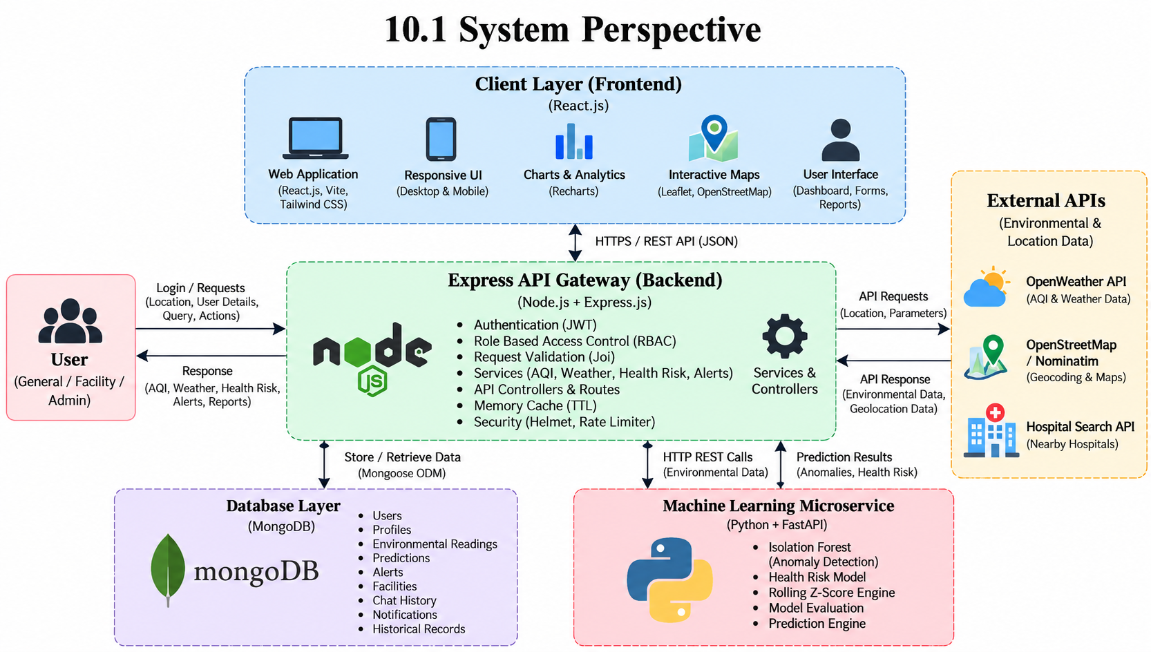

Figure 10.2.1: DFD Level 0 (Context Diagram)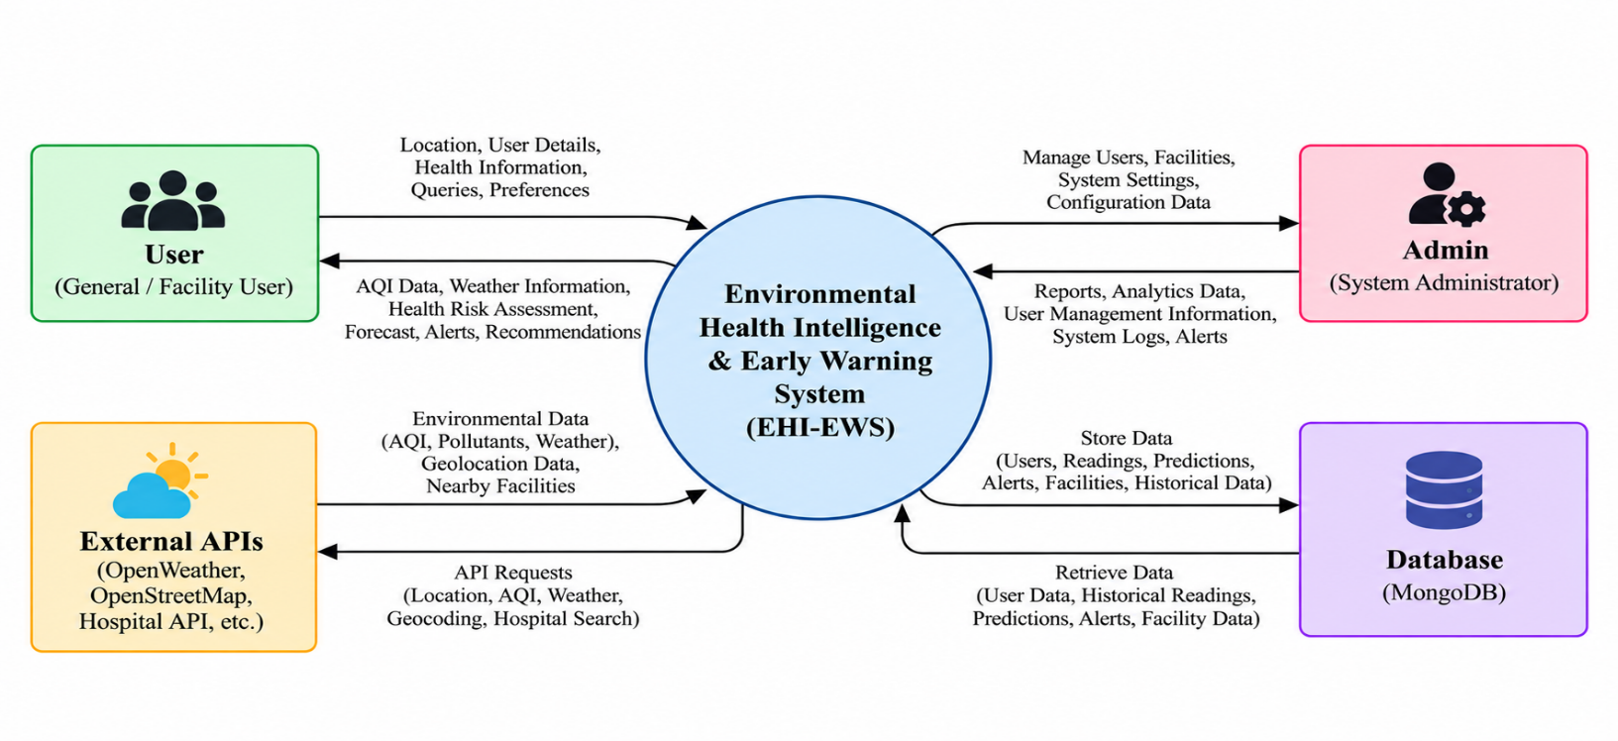

Figure 10.2.2: DFD Level 1 (Main Processes)
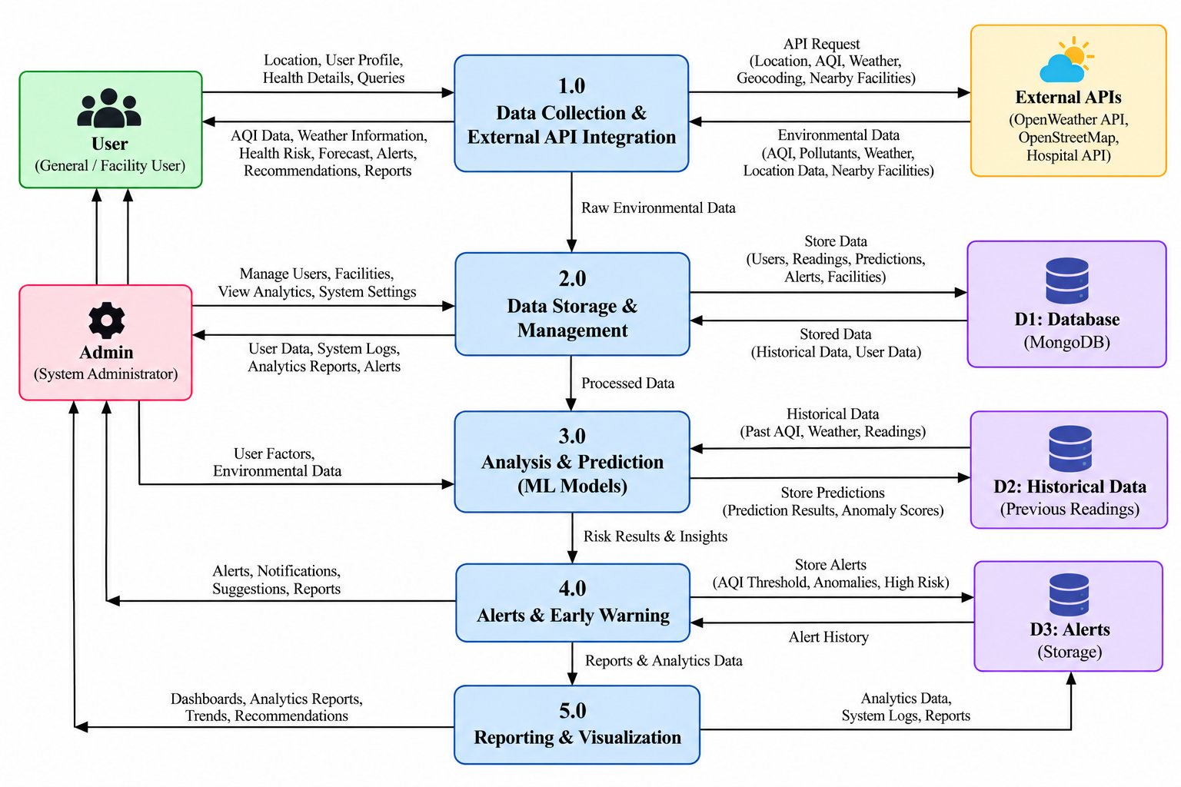

10.3 UML Diagram

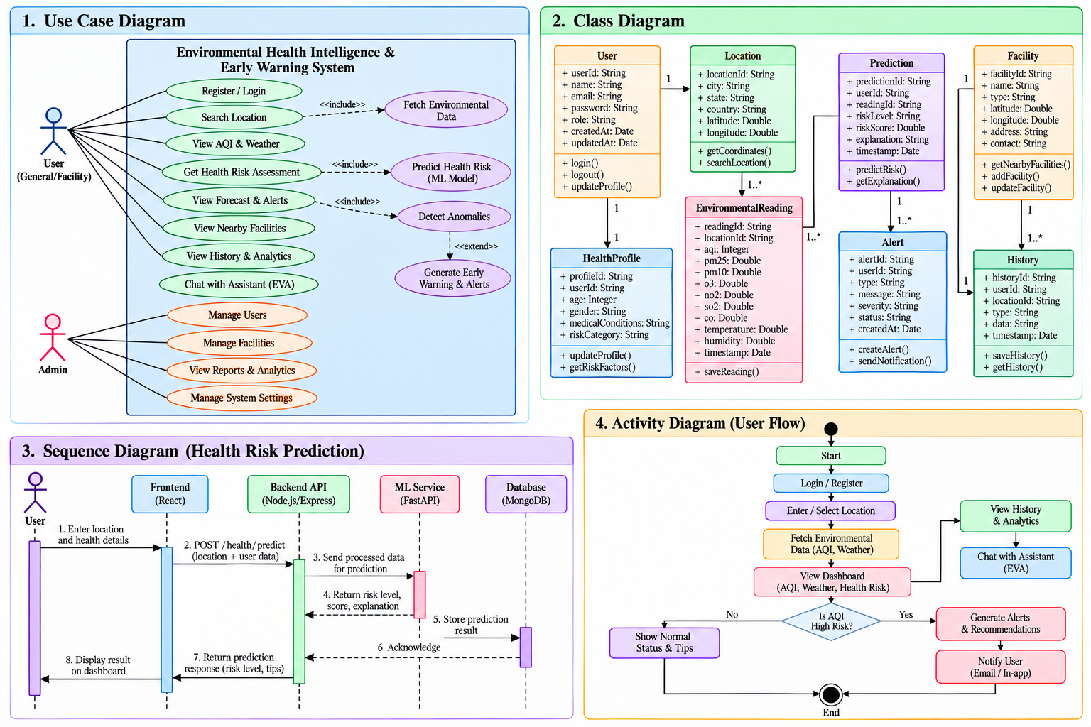
UML diagrams define the object-oriented design and operational behavior of EHI-EWS.
Use Case Diagram Specification
- User / Citizen: Register Account, Login, Manage Profile, View Live AQI, Calculate Exposure, Consult EVA Assistant, Export PDF Report.
- System Admin: Manage Users, Configure Alert Thresholds, Trigger ML Model Evaluation, Oversee Facilities, View Audit Logs.
- Facility Manager: Monitor Indoor Air Index, Update Facility Status, Manage Ventilation Systems.

10.4 Database diagram

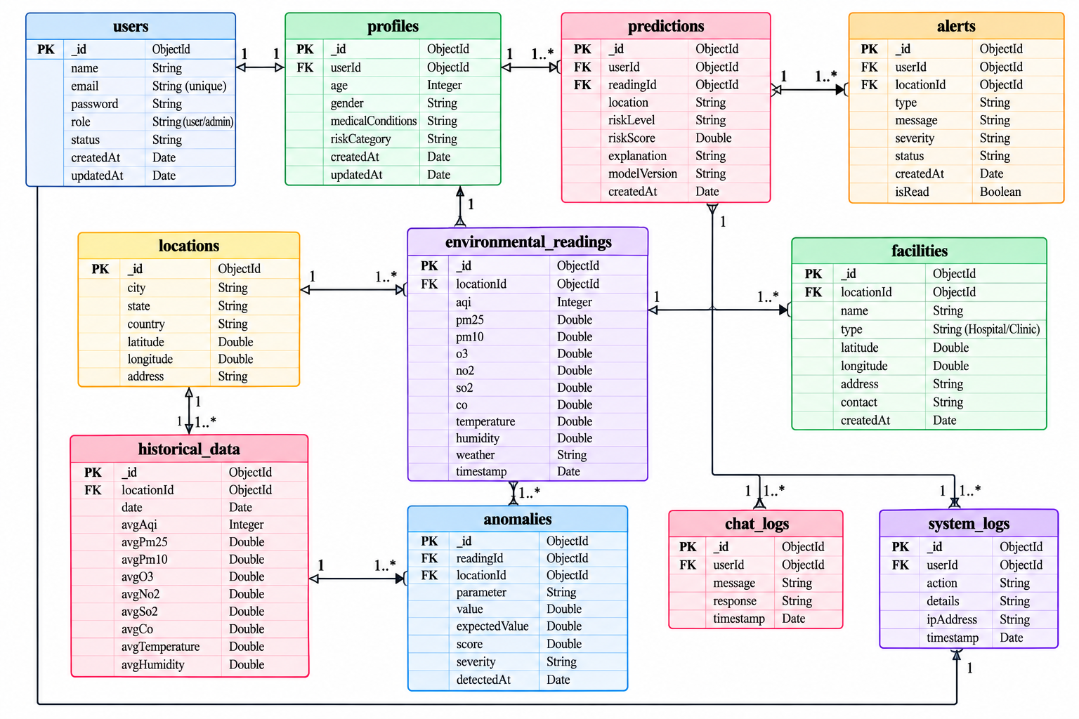
The database schema is organized into 10 normalized MongoDB collections with indexed relationships:
- User to Profile: User (1) ---- (1) Profile
- User to Exposure Record: User (1) ---- (N) ExposureRecord
- Facility to Facility Reading: Facility (1) ---- (N) FacilityReading
- Event to Environmental Alert: EnvironmentalEvent (1) ---- (N) EnvironmentalAlert

10.5 Table Structure

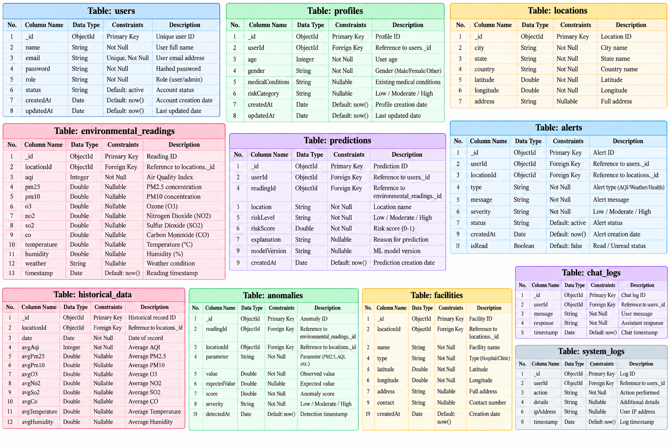

11. SREEN-SHOTS

11.1 Landing page :
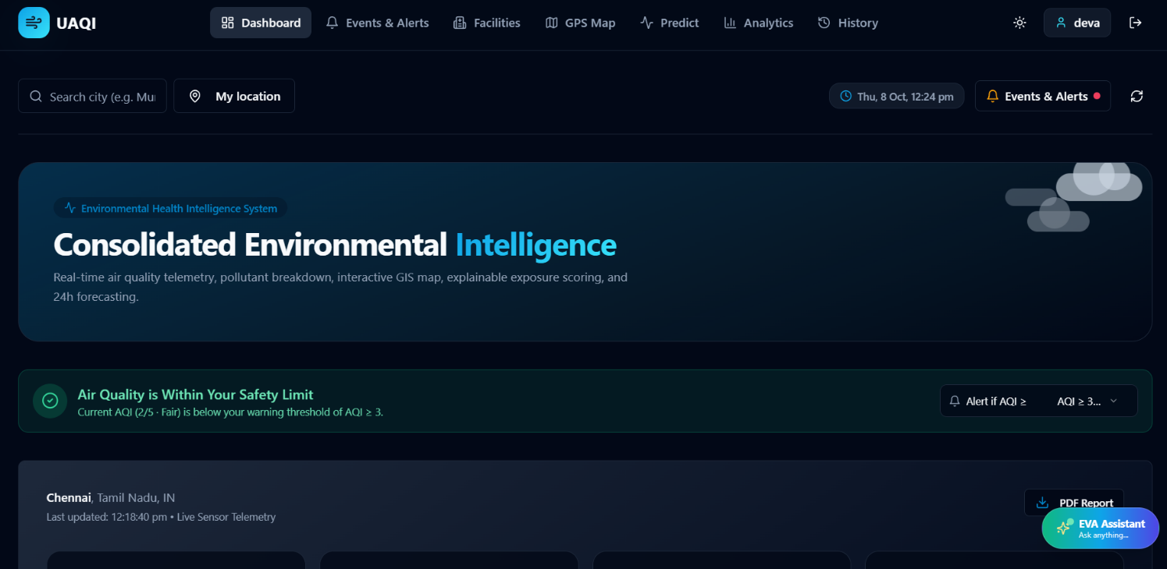

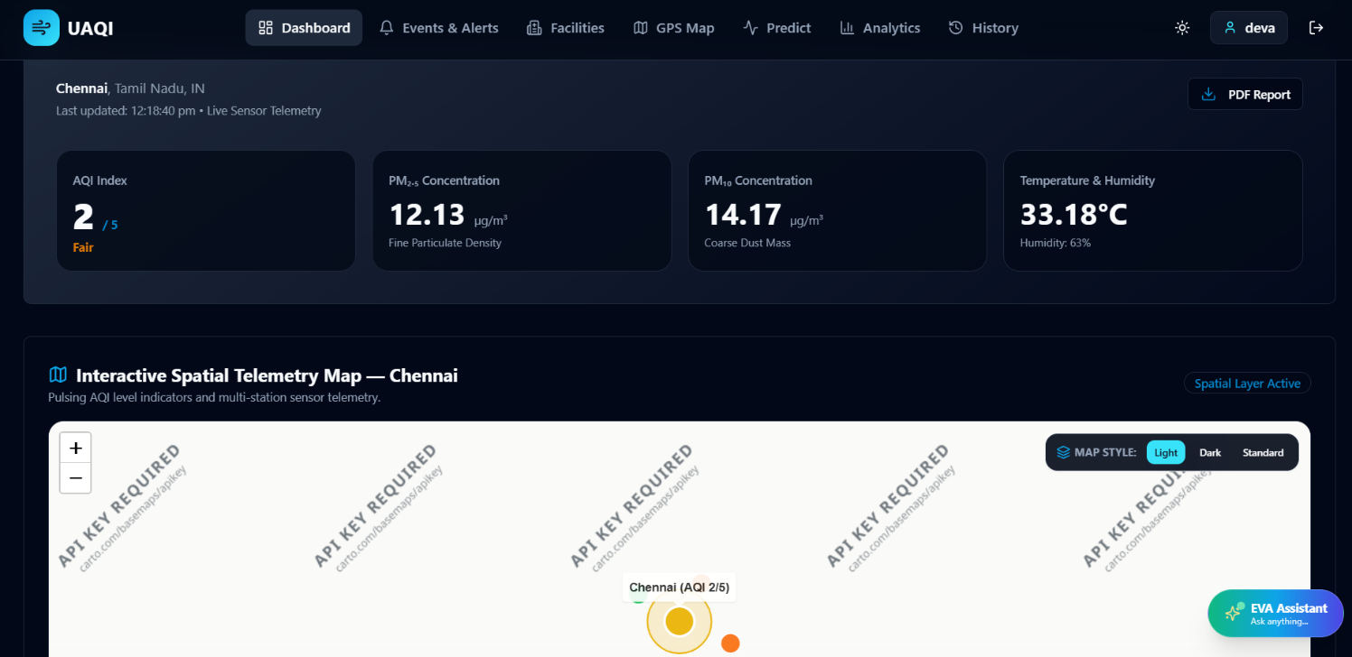

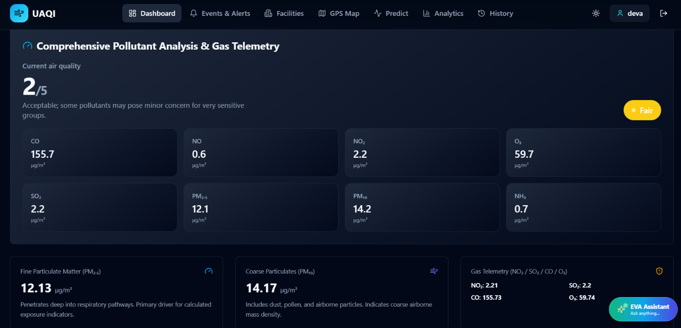

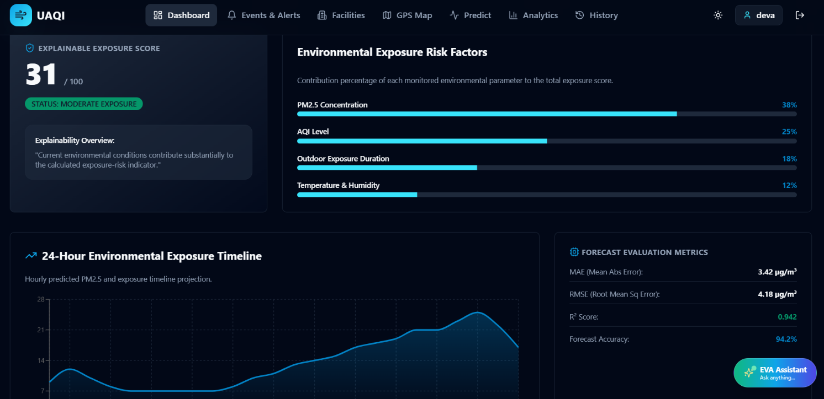

11.2 Events and alerts :
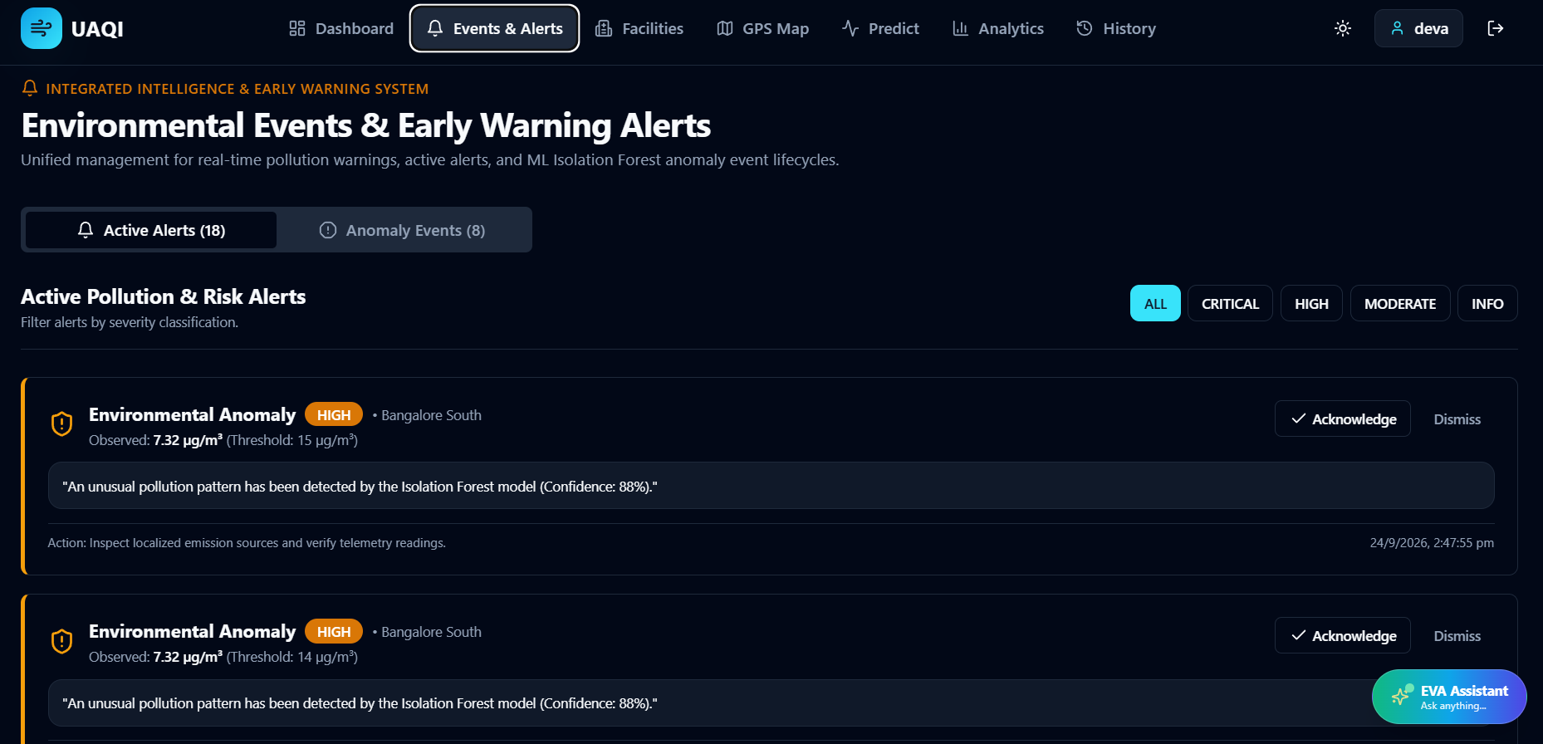

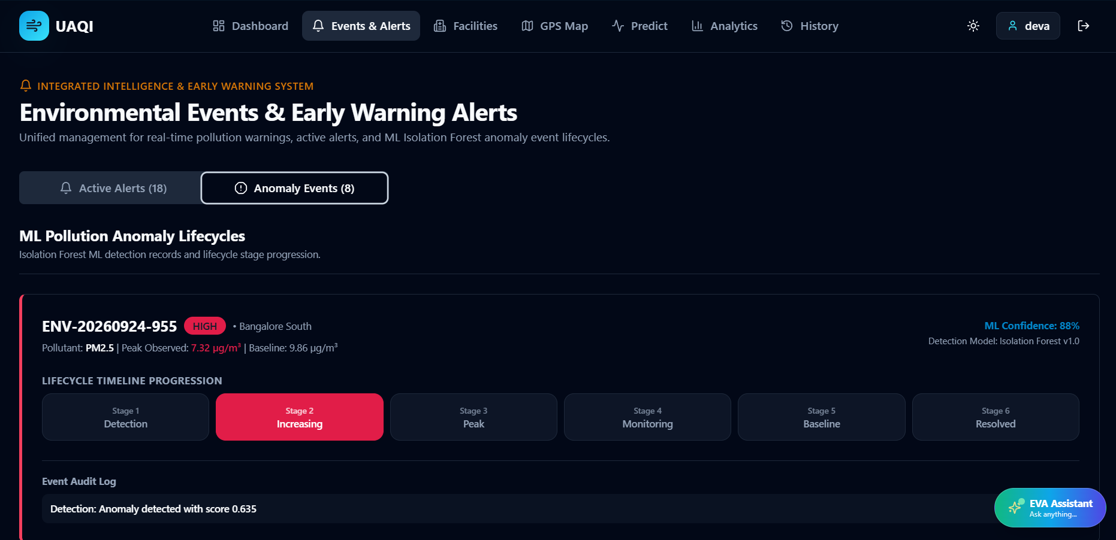

11.3 Facilities
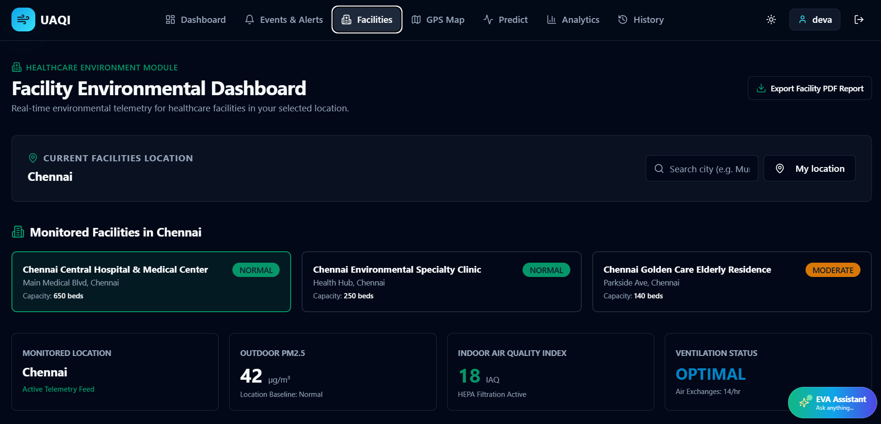

11.4 GIS map:
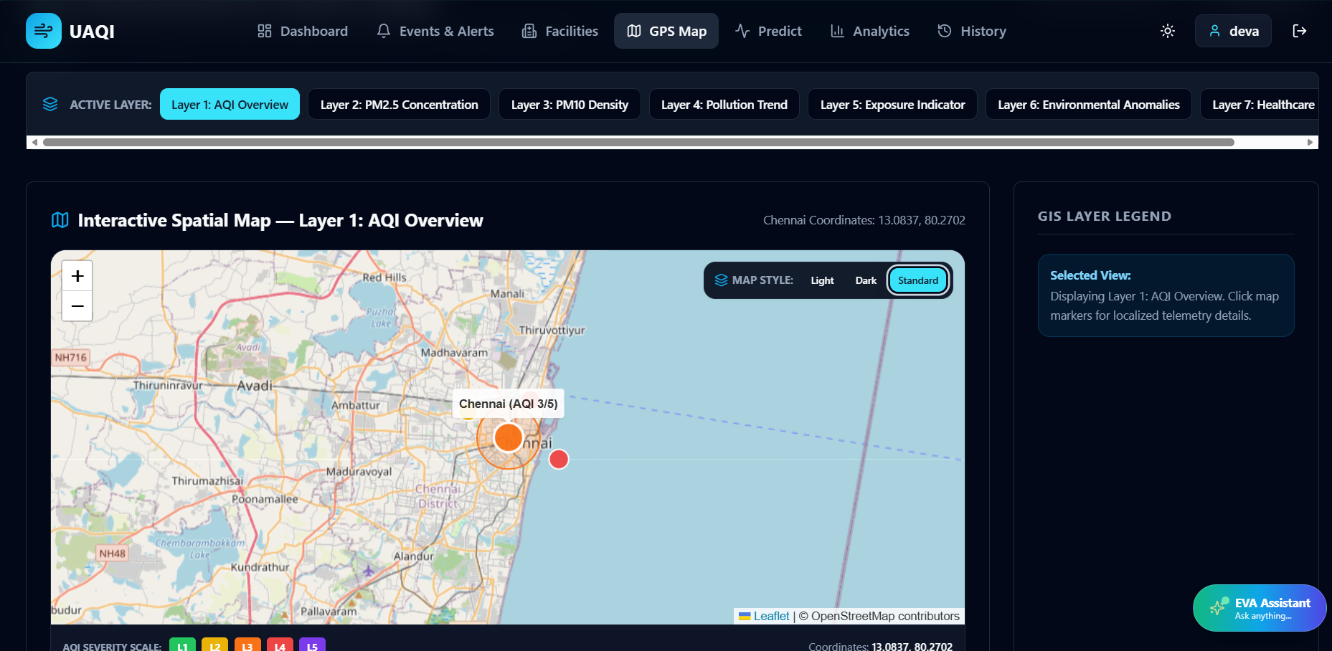

11.5 Prediction :
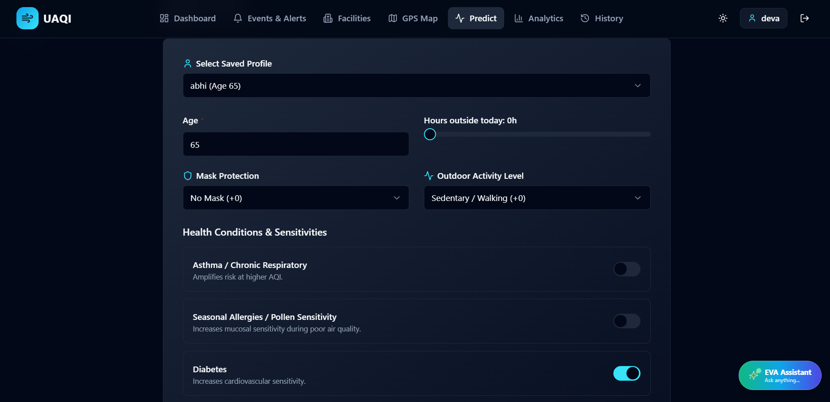

11.6 Analysis :
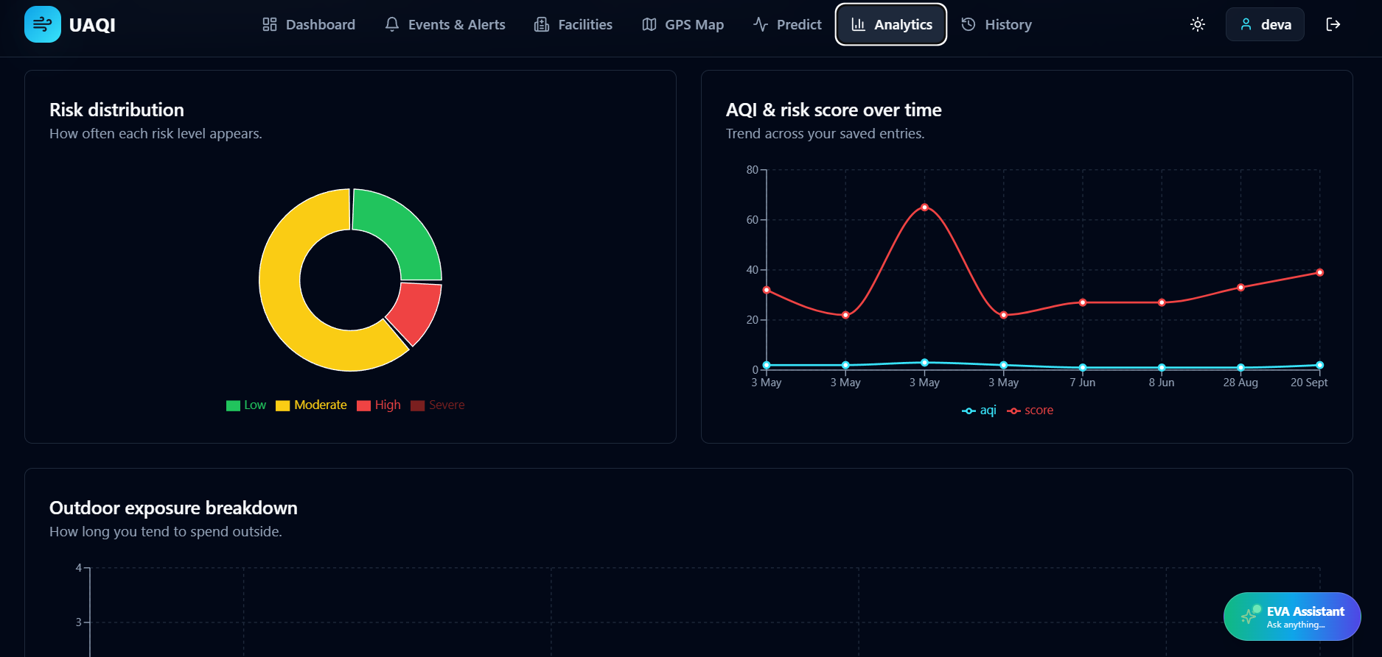

11.7 Analysis :
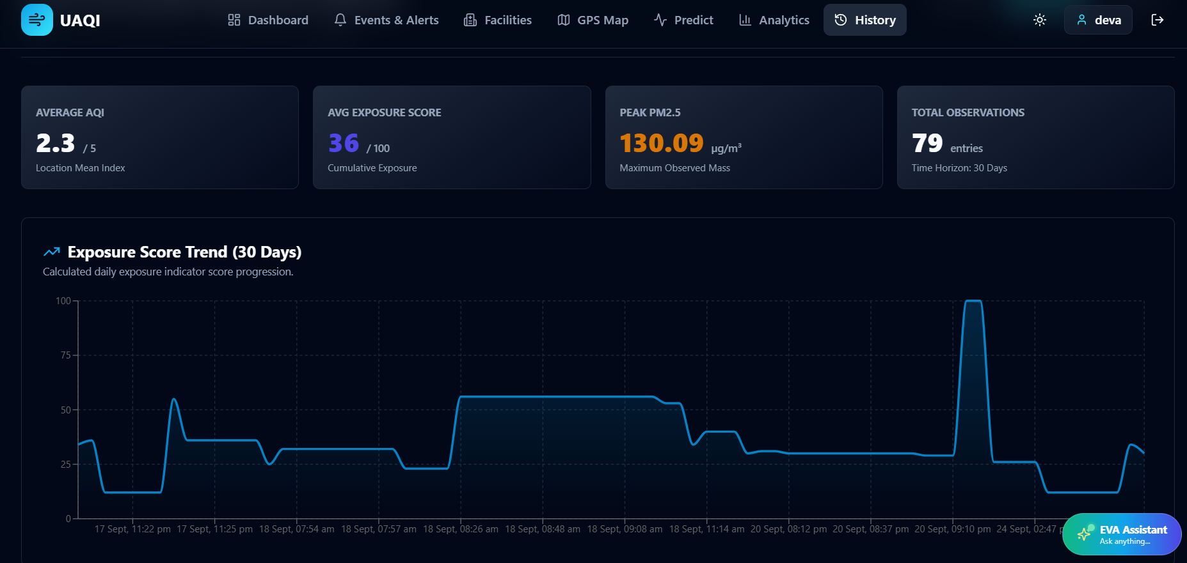
11.8 Eva AI model :
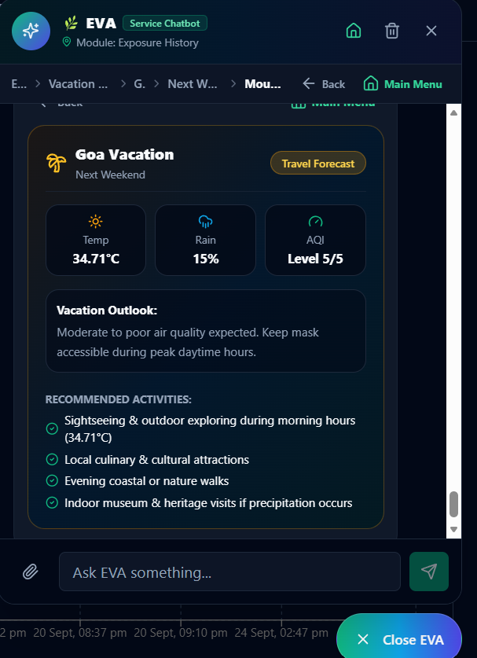
12. Software Testing

12.1 Test Cases
Software testing was carried out to verify the functionality, reliability, security, and correctness of the Environmental Health Intelligence & Early Warning System. The test cases are categorized based on the two primary system roles: Student/User and Admin.

12.1.1 Test Case for Student
Test ID | Test Scenario | Input Data | Expected Result | Status
TC-U01 | User Authentication | Valid email and password | JWT token is returned and the user is redirected to the dashboard. | PASS
TC-U02 | Health Profile Save | Age: 28, Asthma: True | Health profile is saved in the database and EEI risk is recalculated. | PASS
TC-U03 | ML Anomaly Query | PM2.5 array: [25, 30, 180, 22] | FastAPI identifies the spike at index 2 with an anomaly score of -0.42. | PASS
TC-U04 | EVA Hospital Search | Action: FIND_HOSPITALS | The system displays the top 3 nearby hospitals with distance and phone information. | PASS

12.1.2 Test Case for Admin
Test ID | Test Scenario | Expected Result | Status
TC-A01 | Admin modifies global PM2.5 alert threshold from 150 to 120 µg/m³ | Database is updated and the new threshold is reflected in the alert engine. | PASS
TC-A02 | Admin triggers ML Model Evaluation endpoint | System returns RMSE, MAE, and R² evaluation metrics in a table. | PASS
These test cases verify the major functions available to the Student/User and Admin roles, including authentication, health-profile management, anomaly detection, AI-assisted hospital search, alert configuration, and machine-learning model evaluation.
13. CONCLUSION

The “Environmental Health Intelligence & Early Warning System (EHI-EWS)”successfully demonstrates how modern web microservices, machine learning algorithms, and conversational AI can transform public health risk management. Traditional Air Quality Index (AQI) platforms operate passively—outputting static, city-wide numbers that fail to account for individual medical vulnerabilities or provide early warning before environmental pollution spikes occur.
EHI-EWS bridges this critical gap by delivering an end-to-end, proactive health intelligence solution. Built on a robust 3-tier architecture (React 18, Node.js/Express 5 API Gateway, Python FastAPI ML Microservice, and MongoDB Atlas), the project achieved all primary engineering and functional objectives:

1. Personalized Health Risk Assessment:
Transitioned away from generic AQI metrics by implementing the “Environmental Exposure Index (EEI)” algorithm (0–100 scale), dynamically weighting atmospheric pollutant dosages (PM2.5, PM10, NO_2) against individual medical parameters (asthma, COPD, cardiovascular conditions, age, and outdoor exposure time).
2. Real-Time Machine Learning Anomaly Detection:
Deployed a high-throughput Python FastAPI microservice utilizing “Isolation Forest” unsupervised learning and rolling Z-Score statistical models. The engine reliably detects localized pollution surges and sensor anomalies with sub-50ms inferencing latency, outputting standardized evaluation metrics (RMSE, MAE, R2).
3. Conversational AI & Safe Travel Routing (EVA):
Developed the “Environmental Virtual Assistant (EVA)”, combining deterministic menu action trees with NLP intent routing to output clean-air travel itineraries, health recommendations, and real-time medical facility locations via OpenStreetMap/Nominatim spatial APIs.
4. Interactive GIS & Facility Monitoring:
Integrated responsive “Leaflet GIS mapping” with color-coded heatmap overlays, alongside a dedicated “Facility Monitoring Module” to track indoor air quality indices, occupancy capacities, and HVAC ventilation statuses across hospitals and schools.
In summary, EHI-EWS empowers citizens, healthcare administrators, and municipal planners to transition from passive pollution awareness to “proactive, personalized environmental risk prevention”, significantly mitigating the physiological hazards of urban air pollution.

14. LIMITATIONS

Despite meeting all core architectural and functional requirements, the current implementation has a few technical limitations:

1. Dependence on External Sensor Station Density:
The spatial accuracy of ambient pollutant heatmaps and micro-zone exposure scores relies on the geographic coverage and update frequency of third-party telemetry providers (e.g., OpenWeather API). Areas with sparse monitoring stations receive interpolated values.

2. Simulated Hardware Sensor Integration:
Indoor facility monitoring currently relies on REST API payloads and simulated telemetry streams. Direct plug-and-play integration with physical IoT hardware sensors (e.g., MQTT/CoAP protocols) requires additional hardware gateway bridges.

3. Mobile Browser GIS Rendering Load:
Complex Leaflet canvas map renderings with multiple high-density heatmap layers can experience slight frame drops on low-end mobile web browsers.

15. FUTURE ENHANCEMENTS

To further extend the capabilities, precision, and reach of EHI-EWS, future iterations will focus on the following enhancements:

1. Wearable IoT Health Sensor Synchronization:
Integrate directly with commercial wearable platforms (Apple HealthKit, Google Health Connect, Fitbit APIs) to synchronize real-time physiological metrics (heart rate variability, blood oxygen saturation SpO_2, respiratory rate) with environmental pollution exposure.

2. Satellite Remote Sensing & Aerosol Mapping:
Incorporate remote sensing data from satellite missions (such as the European Space Agency's “Sentinel-5P TROPOMI”) to provide high-resolution Aerosol Optical Depth (AOD) mapping in regions lacking ground-level monitoring stations.

3. Deep Learning Multi-Day Predictive Models:
Upgrade the Python ML microservice to incorporate “Long Short-Term Memory (LSTM)” neural networks and “Transformer-based time-series models” for multi-day predictive forecasting of PM2.5 and ozone concentrations.

4. Native Mobile App & Push Notification Engine:
Package the application into native iOS and Android apps using “React Native”, enabling background location tracking and instant mobile push notifications whenever a user enters a high-pollution anomaly zone.

16. REFERENCES
The following references were used for understanding the technologies, frameworks, APIs, machine-learning techniques, database concepts, and environmental monitoring principles implemented in the Environmental Health Intelligence & Early Warning System.
- React Documentation, “React – The Library for Web and User Interfaces,” React Documentation.
- Node.js Documentation, “Node.js – JavaScript Runtime Environment,” Node.js Foundation.
- Express.js Documentation, “Express – Node.js Web Application Framework,” Express.js Documentation.
- MongoDB Documentation, “MongoDB Manual – Database and Data Management,” MongoDB Inc.
- Mongoose Documentation, “Mongoose ODM for MongoDB and Node.js,” Mongoose Documentation.
- Python Software Foundation, “Python Documentation,” Python Programming Language Documentation.
- FastAPI Documentation, “FastAPI – Modern Web Framework for Building APIs with Python,” FastAPI Documentation.
- Scikit-learn Documentation, “Machine Learning in Python,” Scikit-learn Documentation.
- Pedregosa, F., Varoquaux, G., Gramfort, A., et al., “Scikit-learn: Machine Learning in Python,” Journal of Machine Learning Research, Vol. 12, pp. 2825–2830, 2011.
- Liu, F. T., Ting, K. M., and Zhou, Z.-H., “Isolation Forest,” Proceedings of the IEEE International Conference on Data Mining, 2008.
- OpenWeather, “Weather and Environmental Data API Documentation,” OpenWeather API Documentation.
- Leaflet Documentation, “Leaflet – JavaScript Library for Interactive Maps,” Leaflet Documentation.
- Recharts Documentation, “Recharts – Redefined Chart Library Built with React,” Recharts Documentation.
- Tailwind CSS Documentation, “Tailwind CSS – Utility-First CSS Framework,” Tailwind CSS Documentation.
- OWASP Foundation, “OWASP Web Security Testing Guide,” Open Web Application Security Project.
- OWASP Foundation, “OWASP Top 10 Web Application Security Risks,” Open Web Application Security Project.
- World Health Organization, “Air Pollution and Health,” WHO Environmental Health Resources.
- United States Environmental Protection Agency, “Air Quality Index (AQI) Basics,” U.S. Environmental Protection Agency.
- World Health Organization, “WHO Global Air Quality Guidelines,” World Health Organization, 2021.
- MongoDB Inc., “MongoDB Data Modeling and Schema Design,” MongoDB Documentation.

17. APPENDIX
The appendix contains supporting information related to the implementation and operation of the Environmental Health Intelligence & Early Warning System. It provides supplementary material that supports the main chapters of the project report without interrupting the main technical discussion.
The appendix includes sample API interactions, important system configurations, application outputs, sample environmental data, health-risk inputs, anomaly-detection examples, and other supporting information used during the development and testing of the system.

17.1 Supporting Technical Information
A. Sample Environmental Data
A typical environmental reading used by the system may contain the following information:
Parameter | Sample Value
Location | Bengaluru
AQI | 3
PM2.5 | 45 µg/m³
PM10 | 72 µg/m³
CO | 320 µg/m³
NO₂ | 28 µg/m³
SO₂ | 9 µg/m³
O₃ | 48 µg/m³
Temperature | 27°C
Humidity | 62%
Timestamp | Current Date & Time
The environmental reading is processed by the application and can subsequently be used for exposure analysis, health-risk assessment, historical analysis, anomaly detection, and alerts.
B. Sample Health Profile
Parameter | Example
Age | 28
Asthma | Yes
COPD | No
Cardiovascular Risk | Moderate
Sensitivity Tier | High
These factors are used along with environmental conditions to determine the user's potential vulnerability to pollution exposure.
C. Sample Health-Risk Output
Environmental Risk Assessment

Risk Level : HIGH
AQI : 3
PM2.5 : 45 µg/m³
Sensitivity : HIGH

Primary Factors:
• Elevated particulate matter
• Increased environmental exposure
• User sensitivity to air pollution

Recommendation:
Reduce prolonged outdoor exposure and monitor
air-quality conditions before outdoor activities.

D. Sample Anomaly Detection Input
PM2.5 Readings:

[25, 30, 32, 28, 180, 31, 29]
The sudden increase to 180 µg/m³ can be identified as an unusual environmental event by the anomaly-detection component.

E. Sample API Response
{
"location": "Bengaluru",
"aqi": 3,
"pm25": 45,
"pm10": 72,
"temperature": 27,
"humidity": 62
}

F. Sample Alert
ENVIRONMENTAL ALERT

Type : Pollution Spike
Severity : HIGH
Location : Bengaluru
Pollutant : PM2.5

A significant increase in PM2.5 concentration
has been detected.

Recommendation:
Avoid prolonged outdoor exposure and monitor
the environmental conditions.

17.1 USER MANUAL

17.1.1 Introduction
The Environmental Health Intelligence & Early Warning System is designed to help users monitor environmental conditions, understand air-quality levels, assess potential health risks, view forecasts, monitor historical information, and receive environmental alerts.
The user manual provides step-by-step instructions for accessing and using the major functionalities of the system.

17.1.2 System Access

Step 1: Open the Application
Open a supported web browser such as Google Chrome or Microsoft Edge.
Enter the application URL provided by the system administrator.
The login page will be displayed.

Step 2: Register a New Account
If the user does not already have an account:
- Click Register.
- Enter the required information.
- Provide a valid email address.
- Create a password.
- Submit the registration form.
After successful registration, the user can log in to the application.

Step 3: Login
Enter:
- Registered email address
- Password
Click Login.
After successful authentication, the user is redirected to the main dashboard.

17.1.3 Dashboard
The dashboard provides a consolidated view of the user's environmental conditions.
The dashboard displays information such as:
- Current AQI
- PM2.5
- PM10
- Other pollutants
- Temperature
- Humidity
- Weather conditions
- Health-risk level
- Forecast
- Alerts
- Environmental trends
The dashboard is designed to provide the most important environmental information without requiring the user to navigate through multiple modules.

17.1.4 Selecting a Location
The user can search for a location using the location search functionality.

Steps:
- Open the location search option.
- Enter the required city or location.
- Select the desired location from the results.
- The system updates the environmental information.
The selected location is applied to the relevant modules of the application, including:
- AQI
- Weather
- Forecast
- Map
- Environmental analysis
- Nearby facilities
The user can also use the available location functionality to obtain the current location.

17.1.5 Viewing AQI and Pollutants
After selecting a location, the user can view the current air-quality information.
The system displays major pollutants including:
- PM2.5
- PM10
- CO
- NO₂
- SO₂
- O₃
The AQI indicator provides a simplified representation of the current air-quality condition.
Charts and visual indicators help the user understand changes in pollutant concentrations.

17.1.6 Weather and Forecast
The weather module provides information about the selected location.
The user can view:
- Temperature
- Humidity
- Weather condition
- Current weather
- Multi-day forecast
- Environmental forecast information
This information helps users understand the environmental conditions that may influence outdoor activities.

17.1.7 Health-Risk Assessment
The health-risk module provides an assessment based on environmental conditions and the user's relevant health-profile information.

Steps:
- Open the Health Risk section.
- Enter or update the required health-profile information.
- Submit the information.
- The system processes the environmental and user information.
- The resulting health-risk level is displayed.
Possible risk categories include:
- Low
- Moderate
- High
- Severe
The system also provides explanatory information about factors contributing to the risk assessment.

17.1.8 Viewing Historical Data
The history section allows users to review previously recorded environmental and prediction information.
The user can analyze:
- Previous AQI values
- Pollutant trends
- Environmental exposure
- Previous risk assessments
- Historical environmental conditions
Graphs and charts are provided to make trend analysis easier.

17.1.9 Viewing Alerts and Early Warnings
The alert section displays important environmental warnings.
Alerts can be generated for conditions such as:
- High AQI
- Pollution spikes
- Environmental anomalies
- High exposure
- Forecasted elevated exposure
- Facility threshold breaches
Each alert can contain information such as:
- Alert type
- Location
- Severity
- Pollutant
- Message
- Date and time
Users should review high and critical alerts carefully and follow the recommendations provided by the system.

17.1.10 Viewing Nearby Facilities
The system can provide information about nearby facilities such as:
- Hospitals
- Clinics
- Elder-care facilities
- Rehabilitation facilities
- Schools
The user can search for nearby facilities based on the selected location.
Facility information may include:
- Facility name
- Facility type
- Location
- Address
- Contact information
- Distance from the selected location

17.1.11 Using EVA Assistant
The system includes an assistant-oriented feature called EVA.
The assistant can help users access environmental information and perform supported actions.
For example, a user can use the assistant to search for nearby hospitals.
Example action:
FIND_HOSPITALS
The system retrieves relevant nearby facilities and presents the available information to the user.

17.1.12 Admin Manual
Administrators have additional privileges for managing the system.
After logging in with administrator credentials, the administrator can access the administrative functions.
Major administrative functions include:
- User management
- Facility management
- System settings
- Alert configuration
- Analytics
- Reports
- Machine-learning model evaluation
- System monitoring

Managing Alert Thresholds
An administrator can modify configured environmental thresholds.
For example:
Previous PM2.5 Threshold: 150 µg/m³
New PM2.5 Threshold: 120 µg/m³
After saving the configuration, the updated threshold is used by the alert mechanism.

Viewing Analytics
Administrators can view system-level information and analytics to understand environmental events, alerts, predictions, and system activity.

17.1.13 Logging Out
After completing their work, users should log out of the application.

Steps:
- Open the user/profile menu.
- Select Logout.
- The active session is terminated.
- The application returns to the login screen.
Users should always log out when using a shared or public computer.

17.1.14 General User Guidelines
Users should:
- Keep their profile information updated.
- Select the correct location before viewing environmental information.
- Check current AQI before prolonged outdoor activities.
- Review health-risk assessments regularly.
- Pay attention to high and critical environmental alerts.
- Use historical charts to understand pollution trends.
- Use nearby-facility search when required.
- Log out after completing their session.
Note: The system provides environmental and risk-awareness information and should not be treated as a substitute for professional medical diagnosis or emergency medical advice.

18. BIBLIOGRAPHY
- React Documentation, “React – The Library for Web and User Interfaces,” Meta Platforms, Inc.
- Node.js Documentation, “Node.js – JavaScript Runtime Environment,” OpenJS Foundation.
- Express.js Documentation, “Express – Fast, Unopinionated, Minimalist Web Framework for Node.js,” OpenJS Foundation.
- MongoDB Documentation, “MongoDB Manual,” MongoDB Inc.
- Mongoose Documentation, “Mongoose – Elegant MongoDB Object Modeling for Node.js,” Mongoose.
- Python Software Foundation, “Python Documentation,” Python Software Foundation.
- FastAPI Documentation, “FastAPI – Modern, Fast Web Framework for Building APIs with Python,” Sebastián Ramírez.
- Scikit-learn Documentation, “Scikit-learn: Machine Learning in Python,” Scikit-learn Developers.
- Pedregosa, F., Varoquaux, G., Gramfort, A., Michel, V., Thirion, B., Grisel, O., et al., “Scikit-learn: Machine Learning in Python,” Journal of Machine Learning Research, Vol. 12, pp. 2825–2830, 2011.
- Liu, F. T., Ting, K. M., and Zhou, Z.-H., “Isolation Forest,” Proceedings of the IEEE International Conference on Data Mining (ICDM), 2008.
- OpenWeather, “OpenWeather API Documentation – Weather and Environmental Data APIs.”
- Leaflet, “Leaflet – JavaScript Library for Interactive Maps,” Leaflet Documentation.
- Recharts, “Recharts – Redefined Chart Library Built with React,” Recharts Documentation.
- Tailwind CSS, “Tailwind CSS – Utility-First CSS Framework,” Tailwind CSS Documentation.
- OWASP Foundation, “OWASP Top 10 – Web Application Security Risks,” Open Web Application Security Project.
- World Health Organization, “WHO Global Air Quality Guidelines: Particulate Matter (PM₂.₅ and PM₁₀), Ozone, Nitrogen Dioxide, Sulfur Dioxide and Carbon Monoxide,” World Health Organization, 2021.
- United States Environmental Protection Agency, “Air Quality Index (AQI) Basics,” U.S. Environmental Protection Agency.
- World Health Organization, “Ambient (Outdoor) Air Pollution,” World Health Organization, Environmental Health Resources.
- MongoDB Inc., “Data Modeling Introduction,” MongoDB Documentation.
- Pressman, R. S. and Maxim, B. R., Software Engineering: A Practitioner’s Approach, McGraw-Hill Education.
- Sommerville, I., Software Engineering, Pearson Education.
- Elmasri, R. and Navathe, S. B., Fundamentals of Database Systems, Pearson.
- Han, J., Kamber, M., and Pei, J., Data Mining: Concepts and Techniques, Morgan Kaufmann.
- Géron, A., Hands-On Machine Learning with Scikit-Learn, Keras, and TensorFlow, O’Reilly Media.
- Mozilla Developer Network (MDN), “Web Technologies and JavaScript Documentation,” MDN Web Docs.

